1. **Question**

A shopkeeper would like to find the daily average sales for all the items sold by her and record them in a file. She needs a program to do so. Write a Python program with following functions in order to meet her requirement:

1. A function called getDailySales that reads in sales amount for some items sold in a grocery shop for a particular day. The function should store the sales values in a *list* called sales and return it.
2. A function called totalDailySales that accepts sales *list* and calculate the total sales for a particular day. The function should store the total sales values in a variable called total and return it.
3. A function called avgDailySales that accepts sales *list* and calculate the average sales for a particular day. The avgDailySales should call the totalDailySales function for calculating the total sales before finding the average. The function should store the average sales value in a variable called average and return it.
4. A function called avgWeeklySales that calls the getDailySales function for 7 days. The avgDailySales function should also be called after calling the avgDailySales function to find the average sales of each day. The avgWeeklySales function should then write the average sales for each day in the “Average_Sales.txt” file.

After writing all these functions, call the avgWeeklySales function in your Python program. Sample input of the program is as follows:

Finding average sales for day 1

Enter sales amount for the first item [-1 to end]: 89.00

Enter sales amount for the next item [-1 to end]: 58.50

Enter sales amount for the next item [-1 to end]: 14.10

Enter sales amount for the next item [-1 to end]: 199.65

Enter sales amount for the next item [-1 to end]: 78.80

Enter sales amount for the next item [-1 to end]: -1

Finding average sales for day 2

Enter sales amount for the first item [-1 to end]: 144.20

Enter sales amount for the next item [-1 to end]: 23.25

Enter sales amount for the next item [-1 to end]: 12.70

Enter sales amount for the next item [-1 to end]: 75.90

Enter sales amount for the next item [-1 to end]: -1

Finding average sales for day 3

Enter sales amount for the first item [-1 to end]: -1

Finding average sales for day 4

Enter sales amount for the first item [-1 to end]: 45.50

Enter sales amount for the next item [-1 to end]: 125.35

Enter sales amount for the next item [-1 to end]: 89.70

Enter sales amount for the next item [-1 to end]: 48.65

Enter sales amount for the next item [-1 to end]: -1

Finding average sales for day 5

Enter sales amount for the first item [-1 to end]: 120.00

Enter sales amount for the next item [-1 to end]: 98.45

Enter sales amount for the next item [-1 to end]: 58.35

Enter sales amount for the next item [-1 to end]: 89.90

Enter sales amount for the next item [-1 to end]: 88.55

Enter sales amount for the next item [-1 to end]: 77.70

Enter sales amount for the next item [-1 to end]: -1

Finding average sales for day 6

Enter sales amount for the first item [-1 to end]: 78.50

Enter sales amount for the next item [-1 to end]: 125.00

Enter sales amount for the next item [-1 to end]: 360.10

Enter sales amount for the next item [-1 to end]: 47.10

Enter sales amount for the next item [-1 to end]: 98.35

Enter sales amount for the next item [-1 to end]: 78.50

Enter sales amount for the next item [-1 to end]: -1

Finding average sales for day 7

Enter sales amount for the first item [-1 to end]: 564.00

Enter sales amount for the next item [-1 to end]: 52.00

Enter sales amount for the next item [-1 to end]: 21.35

Enter sales amount for the next item [-1 to end]: 211.20

Enter sales amount for the next item [-1 to end]: 85.00

Enter sales amount for the next item [-1 to end]: -1

Take note that there are no sales recorded on day 3 in the example above as the shop was closed due to Public Holiday. Text file written for the above inputs is given in Figure 1 below:

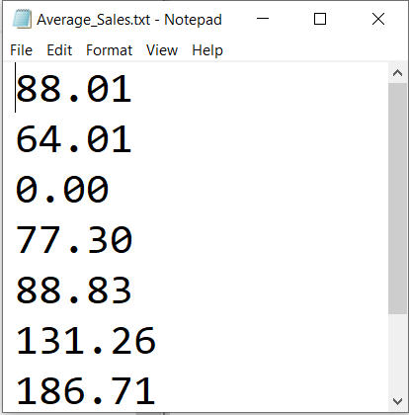

Figure 1: “Average_Sales.txt” File